TU872 EMA

Karen Downard

Make Poverty History: a case of institutional development in campaigning for poverty reduction

10th October 2014

Executive Summary
This report analyses the Make Poverty History (MPH) campaign as an instance of institutional development; not in the sense of the institutional development that it achieved, but to the extent that it was institutional development.
It was institutional development in the way that campaigning is done by organisations seeking to reduce poverty. The coalition took on the new form of a network of networks, it used media and celebrities to an unprecedented extent in this field, and it was closely linked with top politicians. Consequently it achieved a level of public awareness and mobilization that had not been achieved before, although the actual results of the campaign were not as hoped.
This new form of campaigning encountered new dangers and difficulties; the danger of being co-opted by politicians or having your agenda overshadowed by celebrities and the difficulty of getting the message right for different audiences.
This is a new form of campaigning. It is not a blueprint model but it is a model that can be learned from by those interested in campaigning for an end to global poverty.

1.Introduction
I have chosen to write this report on the MPH campaign because I went on the Edinburgh rally in 2005 and encouraged others to do so. I found the campaign inspirational but the achievements, ultimately, were disappointing. Therefore it is of interest to study both how the campaign achieved the levels of public awareness and mobilisation that it did, and the reasons why so little was achieved as regards campaign aims. Sireau writes that, in June and July 2005, media coverage, most of it favourable, “reached 69 per cent of the UK adult population, with each adult exposed an average of 12 times”. (2009, p23) When it came to taking action 440,000 emailed the Prime Minister and 225,000 came to the rally. (MPH, 2005) That has to be regarded as a successful campaign in terms of public awareness and mobilization. Establishing what was actually achieved by the campaign depends to some extent on whose report you read. MPH pointed to promises made on aid and debt and said, “The campaign ensured that global poverty was placed higher on the national and global agenda than ever before”. (MPH, 2005) The World Development Movement (WDM) produced an assessment of G8 action one year on. This concluded that useful progress had been made on debt cancellation, a little on aid, but there had been no change to global trade rules. (WDM, 2006). However the promise to meet the target of 0.7% of GDP being spent on aid was met, by the UK at least, in 2013. Oxfam put this success down to the MPH campaign. (Oxfam, 2013)
The aim of the campaign was to tackle poverty through more and better aid, debt cancellation and trade justice. It was asking for major changes to the international economic system, so that it favoured poor countries rather than rich ones. (Sireau, 2009) If that had been achieved it would have been a massive case of institutional development and I would have been writing a report on institutional development in the world economic system. Even so, to achieve such favourable responses to the suggestion of such changes is institutional development in people’s values and norms. However the aspect of institutional development represented by MPH which I will be focussing on is campaigning strategies.
The institutional landscape that formed the context for the MPH campaign included big players in the form of the G8 leaders, who had the power to change the rules. The public in the UK and other countries also represent a big player, as they would give the G8 leaders the mandate to change the rules and would put pressure on them to do so. On a mesa rather than a macro level, the big players were the coalition members who had to negotiate how the coalition was going to work given their many differences. The neoliberal rules which govern the functioning of the global economic order are an institution which MPH sought to affect.
The materials I have used include two books and two academic papers, journal articles, news reports and the websites of some of the coalition members.

2. Analysis of the case
MPH is a case of institutional development because it was an unprecedentedly large and broad coalition. It consisted of over 500 organisations including charities, campaigns, trade unions, local organisations and faith, humanitarian and environmental groups. The activists were overwhelmingly moderate in their campaign methods, as compared to more confrontational forms of direct action used by anti-globalisation protestors. (Roots and Saunders, 2007) It was different to have a campaign focussed on a G8 Summit that was non-violent but it also needed to be big in order to attract the media coverage ordinarily given to the smaller, more disruptive campaigns. MPH was also different in that it was endorsed by politicians and had huge celebrity involvement, making it a year-long media fest. (Sireau, 2009) MPH did have an antecedent in Jubilee 2000, which was also a coalition based around a time-limited campaign. However MPH was so much bigger and broader, its use of celebrities and mass media so extensive and its aims so much more ambitious, that I believe it qualifies as a case of institutional development in campaigning strategy.
Negotiations that led to the formation of MPH began with some NGO representatives meeting at the Oxfam office to discuss how they could use the UK presidency of the G8 to bring global poverty onto the agenda. Soon after a meeting hosted by Gordon Brown included Bob Geldof of Live Aid and Richard Curtis of Comic Relief. This set the principle actors and the core issues of trade, aid and debt. (Sireau, 2009)
Based on Payerhin and Zirakzadeh’s definition in Rootes (2009), MPH was a coalition not a movement and it did not seek to develop an overarching campaign identity. The member organisations all retained their separate identities and communicated directly with their supporters on campaign issues. It was always intended that the coalition would end after the year of the campaign had been completed. This organisational form has been described as “a network of networks”. (Saunders and Rootes, 2006) The campaign was able to take advantage of the large number of potential supporters represented by the membership of all the groups in the network. Necessary to a network of networks is a frame, around which a large number of people can be mobilised, and a coordinating body. (Papaioannou et al., 2009)
Papaioannou et al. describe framing as “the definition of an issue as being a problem; the articulation of a blame story; the suggestion of a solution and motivating of a moral appeal around this problem”. (2009, p811) The frame used by MPH was one of justice not charity; it blamed the rich nations for the plight of the poor and pointed to its three demands on aid, debt and trade as the solution. It did not propose a radical challenge to neoliberalism. This was the frame that was likely to be the least contentious to coalition members and therefore result in the largest mobilization possible. (Saunders and Rootes, 2006) Divisions did arise however, over messaging and the close association of the campaign with the Labour Party. Divisions became more pronounced in the responses made to the outcome of the G8 Summit and to Live8.
The inter-organisational relationship most apparent in MPH was coordination. It had a Coordination Team made up of representatives of the major networks and organisations within the coalition. This team took on strategic oversight of the campaign. (Sireau, 2007) No one organisation had leadership of the campaign but some had more influence than others due to resources or connections. Those who had these had more power to direct the way MPH operated. An example of this was Comic Relief whose vice-chair Richard Curtis was able to bring in vast amounts of pro bono marketing and donated advertising space, as well as celebrity involvement. This meant that those who wanted marketing that had a simple message aimed at popularizing the appeal won over more radical groups like the WDM, which wanted a message explaining the causes of poverty. (Sireau, 2007)
MPH also found itself in competition with a similar but different agenda, expressed in the Commission for Africa Report and by Live8. Both of these were spearheaded by Bob Geldof whose focus was African poverty and aid. MPH could not control the messages that came out of Live8, which resulted in an unintended focus on Africa and a weakening of the justice frame. (Sireau, 2009) The campaign book produced by MPH said that the Live8 concerts were to be about justice not charity and encouraged people who couldn’t go to Edinburgh to be part of Live8. (Bedell, 2005) However Sireau made it clear that the emphasis at the concerts was on Africa and not MPH’s demands. (p192)
The MPH brand was an important coordinating feature of the campaign and the Coordinating Team was keen that the logo should have prominence on all banners and communications used by member organisations. Oxfam was praised for its unselfish organising of the Nelson Mandela event in February, which came across totally as a MPH event. (Sireau, 2009) Of course, it was tempting for smaller organisations to use the MPH campaign to get their own agency’s name heard and seen. This need to be recognised can be an issue when organisations try to coordinate their efforts. (TU872, Part 2) However Oxfam, which was by far the biggest and most powerful organisation in MPH, was criticised over another contention within the MPH coalition; the close association with the Labour Party, which led some to believe the campaign had been co-opted by the government. (Hodkinson, 2005)
Working with other organisations is difficult and one of the things it requires is the recognition of difference; different views and different levels of power. (TU872, Part 2) These differences were not really recognised in the MPH campaign, which after all was only going to have to last a short time. For most organisations it was worth putting up with the differences of opinion and power relations for the benefit of being part of such a well-publicized campaign. (Sireau, 2009)

3. Discussion of lessons
Below is a model of the relationships between the organisations and individuals that made up MPH. This shows how MPH worked. The arrows indicate the direction of influence, if any, and a double headed arrow indicates that there was influence in both directions. Outside of the system are the Commission for Africa Report and Live8 because they were not formally a part of MPH but had an influence on it. This is an annotated model and I have added lessons that can be learned from the MPH experience in blue.
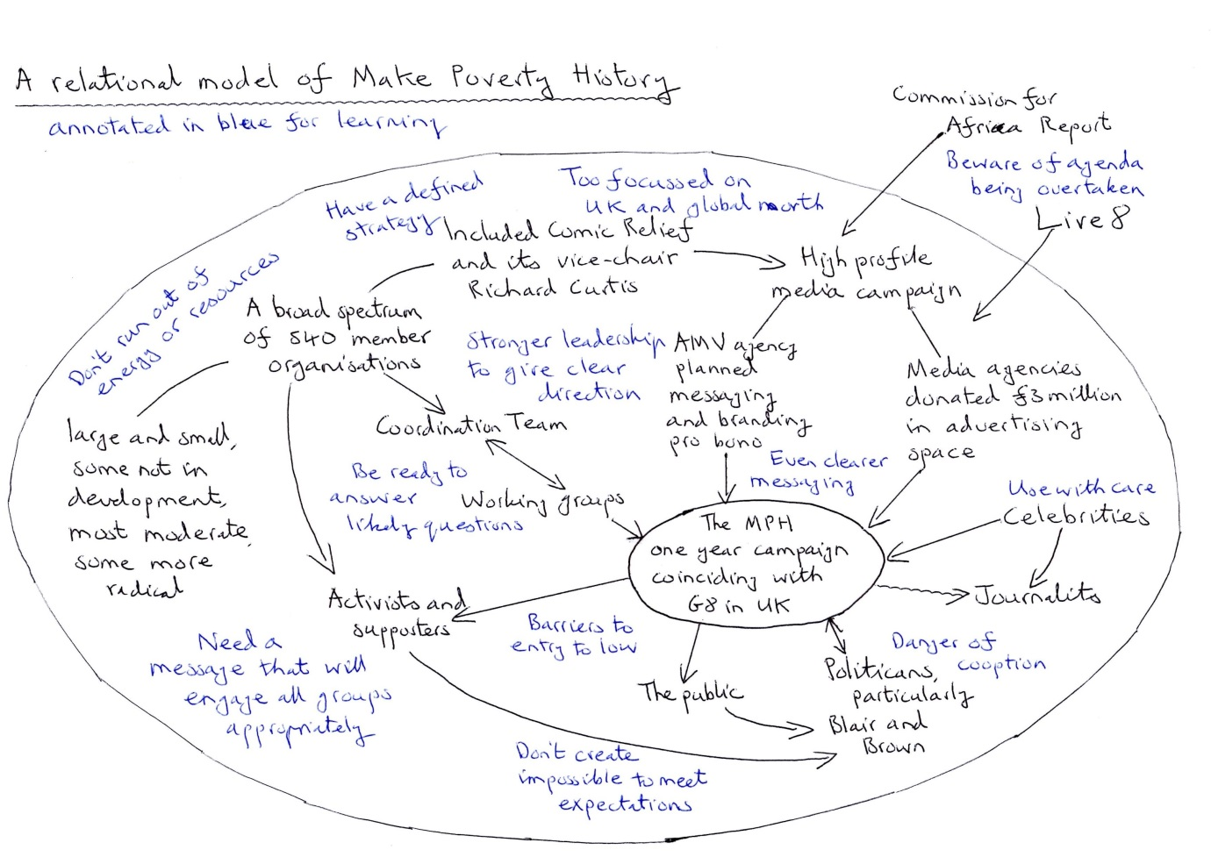

It can be seen from the model that the key elements that made up the campaign were the broad spectrum of member organisations, the high profile media promotion, the celebrities and the political endorsement from Tony Blair and Gordon Brown. It was these features that made the campaign what it was. The groups the campaign hoped to influence were the G8 leaders, including Blair and Brown, the general public, supporters and activists of the member organisations and journalists. It was intended that the public, supporters and activists would influence the politicians. The role of the celebrities was to get the campaign into the media frequently, thereby increasing public awareness and mobilisation.
The campaign itself was run through working groups made up of people from the member organisations. Anyone could attend the working groups so the leaders of the groups were never sure who was going to attend and issues often had to be gone through a second time. (Sireau, 2009) The working groups influenced the campaign and the coordinating team. The member organisations had influence on the coordinating team, according to their relative power or size, and the coordinating team also influenced the working groups.
This model shows a development in the way NGOs can go about campaigning on an issue. Nothing so big or so media focussed had been tried before. It cannot be considered a blueprint however as it was dependent on circumstances and people that are unlikely to be the same again. Lessons can be learned from where difficulties occurred.
MPH focussed too much on the UK and certainly was missing the voices of the Global South. The global branding was lost when other countries choose the name Global Call to Action against Poverty. The campaign did not take off in other countries as it did in the UK. It was partly to address this that the idea for the Live8 concerts came into being. Even so the campaign received much less media coverage outside the UK and only the Washington Post in America covered the politics of Live8. (Sireau, 2009) Social and political movements in the Global South were angry at their lack of representation and that the campaign appeared to be about Northern NGOs and white celebrities saving the helpless. (Hodkinson, 2005) From the very beginning a future campaign would need to be truly representative.
The loose network of organisations that made up MPH lacked a strong leadership to give it a clear direction and a defined strategy. This led to difficulties having a unified message and whether to praise the G8 or criticize it. MPH mixed both insider and outsider strategies, which can be effective, but everyone needs to understand the strategy and agree with it or it will lead to distrust within the coalition. Campaigning from the inside also carries the danger of the message being co-opted by the politicians for their own purposes and even of people thinking it was the government’s idea. (Sireau, 2009) At the risk of losing some members, decisions needed to be made about strategy and messaging and kept to.
The messaging needed to be developed in two ways. Firstly the clear and simple message planned by the advertising agency Abbott Mead Vickers (AMV) still did not adequately get across the concept of trade justice. People did not understand that the rules of trade had to be changed if the benefits of aid and debt cancellation were to be long term. Secondly the messaging was not appropriately deep and thought-through enough for activists and supporters. The MPH website did no more than refer users to member organisations’ sites. There was a need to be able to answer likely questions, such as aren’t countries poor because they are corrupt.
Celebrities were a vital part of MPH’s success. (BBC, 2005) However they made the messaging even harder to control as they might not say what was expected or wanted. Some were concerned about celebrities’ legitimacy, as to whether they were truly engaged with the issues they were championing. (Sireau, 2009) This second problem could not be said of the central celebrities in the campaign: Nelson Mandela, Bono, Bob Geldof and Richard Curtis, who are known for their development work. However people cringed at some of Bono’s comments (Quarmby, 2005) and Bob Geldof was instrumental in the agenda being overtaken by Africa. It is also uncertain how attending a free concert could be of help to the campaign. A criticism of the campaign was that the barriers to entry were too low - attending a concert or wearing a white band that had become a fashion item – which meant people’s awareness of the issue did not change and they did not count in the eyes of the politicians. (McNeill et al., 2012)
Finally MPH was a one year campaign focussing on the G8. By its name the campaign, inadvertently I think, created the expectation that poverty could be ended in a year. When this did not happen there was the danger that people would become disillusioned and not be interested in campaigning again. The focus being on the G8 Summit in July meant that resources, particularly human resources, were concentrated on that event and the campaign ran out of steam after it, as staff were pulled back and publicity reduced. The more difficult issue of trade rules was still to be handled later in the year. There are lessons to be learned here in naming your campaign carefully and managing resources over the entire time the campaign is running.

4. Reflection
I will reflect on the institutional development brought about by MPH by considering another attempt which was made by a coalition of organisations to influence the G8 when it met again in the UK in 2013. This was the Enough Food If campaign. Although the IF campaign said it wasn’t a successor to MPH, it was probably seen as such and was certainly the biggest joint campaign since 2005. (EnoughFoodIF, 2013) I think it was based on the institutional development achieved by MPH. IF learned lessons from MPH and the fact that it has less impact was probably more to do with a different political situation than failures on its part. MPH was still a good model to build on, not one to replicate but a learning model.
Investigating this case I found out about the behind the scenes politics of the campaign that I had not been aware of before and some of the criticisms made of it too. I had similar feelings about the Live8 concerts, that they overshadowed the rally, as were expressed by people interviewed by Sireau. (p193) However I see now how the celebrity input made such a difference to the amount the campaign was in the media, which was essential to achieving public awareness on a wide scale. I learned that having an insider track to politicians, one of whom at least was on side anyway, was a key factor in what MPH was able to achieve. Even so my reading caused me to conclude that MPH did not achieve nearly as much as was hoped for and the IF campaign was even more disappointing. To change the rules of the game so that they favour the poor over the rich, when it is the norms and values of rich people and the big player represented by the rich nations that have to change, is a formidable task.

References
BBC (2005) Why Live8?: What is Make Poverty History? [online], www.bbc.co.uk/music/thelive8event/whylive8/povertyhistory.html (Accessed on 23 September 2014).
Bedell, G. (2005) MAKEPOVERTYHISTORY: How You Can Help Defeat World Poverty in Seven Easy Steps, London, Penguin Books.
EnoughFoodIF (2013) EnoughFoodIF: Frequently Asked Questions [online], http://enoughfoodif.org/faqs (accessed on 28 August 2014).
Hodkinson, S. (2005) “Inside the Murky World of Make Poverty History”, Red Pepper, 27.06.2005 23:16 [online], www.indymedia.org.uk/en/2005/06/315058.html (Accessed on 27 August 2014).
Make Poverty History (2005) Make Poverty History: Achievements [online], www.makepovertyhistory.org/achievements/ (Accessed on 23 August 2014).
McNeill, K., Doane, D, and Tarman, G. (2012) “The lessons from Make Poverty History”, The Guardian, 31 May 2012, [online] www.theguardian.com/voluntary-sector-network/2012/may/31/make-poverty-history (Accessed on 23 August 2014).
Open University (2013) TU872 Institutional Development: theory, policy and practice, part 2, Milton Keynes, The Open University.
Oxfam (2013) Make Poverty History, and the G8 promises – was it all really worth it? [online], www.oxfam.org.uk/media-centre/press-releases/2013/05/make-poverty-history (Accessed on 23 September 2014).
Papaioannou,T., Yanacopulos, H. and Aksoy, Z. (2009) “Global Justice: from Theory to Development Action”, Journal of International Development, Vol. 21, p805-818.
Quarmby, K. (2005) “Why Oxfam is Failing Africa”, The New Statesman, Vol. 134, Issue 4742, p10-12.
Rootes, C. (2009) “Book Review: Make Poverty History”, Social Movement Studies, Vol. 8, No. 4. p465-467.
Rootes, C. and Saunders, C. (2007) “Demonstrations of Democracy: The Make Poverty History and Stop Climate Chaos marches”, European Consortium for Political Research, Helsinki, 7-12 May 2007, University of Kent.
Saunders, C. and Rootes, C. (2006) “The ‘Movement of Movements’ as a ‘Network of Networks’ The Global Justice Movement and the ‘Make Poverty History’ march”. Unpublished paper, University of Kent.
Sireau, N. (2009) Make Poverty History: Political Communication in Action, Basingstoke, Palgrave Macmillan.
World Development Movement (2006) Small Change [online], www.wdm.org/uk/small-change (Accessed on 27 August 2014).

